**Title: Modelling and Performing a Life Cycle Assessment of a Prospective Stage Pre-FEED Solar Farm**

**Authors:** Ryan Isaac Lazaroo 1, Munish Kumar 2

1 Nanyang Technological University, 2 Singapore University of Social Sciences

*Corresponding author. Email: RYAN017@e.ntu.edu.sg

**Abstract:**

As more solar developments are built, there is a need to study their environmental and financial impact. There are currently a limited number of studies regarding the life cycle assessment (LCA) of a solar farm as a whole. Instead, most LCAs focus on the individual components of the solar farm (for example, solar panels or power cables). Many of these analyses are also done after the solar farm is operational. Once operational, it is difficult to mitigate the effects of high emissions costs. In this paper, we model and perform the LCA for a prospective solar farm in its earliest stages of conception. By this, what we mean is that the modelling is performed as part of the “prospective stage pre front end engineering and design (prospective stage pre-FEED)” of the expectant solar farm, but before the final investment decision (FID) has been made. Using analogues, careful assumptions, and public sources, we model the energy production, carbon emissions, and costs of a solar farm over its life cycle.

We learn from our modelling that battery decommissioning is the largest source of emissions followed by the manufacturing of solar panels and batteries, resulting in peak emissions at the start and end of the solar farm life cycle. The years where batteries replacement is modelled to occur also shows high emissions compared to the lower baseline operational emissions. As batteries are a largest source of emission, the number and deployment of batteries, if used at all, should be considered prior to commencing operations to reduce both emissions and costs through optimization. optimization. Finally, we evaluate the costs and payback period of the solar farm and find that the number of years before payback aligns with the 2-to-13-year period indicated by literature.

**One-Sentence Summary:**

We model and perform a life cycle assessment of a prospective solar farm at the early stages to identify possible mitigations in emissions and costs.

# Introduction

Solar energy is an increasingly cheap source of energy that has been growing rapidly due to its modular and versatile nature. As an alternative energy source, solar energy is often touted as a ready replacement for fossil fuels. Solar power generation can be done on multiple scales, from large utility-scale projects that provide cheap electricity to smaller rooftop panel installations that help building owners offset their electricity bills.

Another reason for its attractiveness is that electricity generation from solar is carbon negative and the sun is a limitless source of energy. If appropriately harnessed, it can potentially keep up with growing energy demand while meeting ambitious climate targets. Coupled with improvements in solar PV technology, the increase in adoption of solar energy is therefore not a surprise.

External factors such as the ongoing war in Ukraine has heightened energy security concerns and accelerated the adoption of renewables, with some forecasts estimating solar PV capacity to exceed that of natural gas and coal by 2027 (IEA, 2022; IEA, 2023). In 2022, solar PV generation increased to nearly 1300 TWh worth of energy, accounting for XX% of global energy demand.

However, there are challenges with solar developments. It is not an “on-demand” energy source; it very much depends on the amount of solar irradiance available, so coupling it with battery storage gives it greater flexibility of use. Depending on how the solar development is planned and the amount & types of batteries used; its carbon footprint can vary widely. Batteries additionally add a significant Capital Expenditure (CAPEX) cost, which directly impacts the payback period of the project.

As the number of solar developments around the globe increase, there is a need for novel approaches to analyse the energy production potential, greenhouse gas (GHG) emissions, and total cost of the development over its entire life cycle. It is especially important to evaluate these early in the development to optimise costs as well as plan for the mitigation of potential GHG emissions and the associated carbon taxes and costs they might incur. Thus far, early LCA has been a challenge due to the lack of data on exact energy production and emissions prior to commencing operations.

However, in this paper, we will demonstrate that it is possible to use estimates of production, emissions, and costs from existing solar developments and component manufacturers to evaluate the full life cycle of solar development, at the “prospective stage pre-FEED”. The solar development we will model is located on an offshore equatorial location, requiring subsea cabling to connect to an onshore electrical grid. Our model considers the full “cradle-to-grave” view of the development, where we consider: (a) the initial operational planning of the farm including installation of underground pipes and high voltage electrical cables groundwork, (b) logistics and shipping for major “off-the-shelf” parts and components like solar panels & inverters, and (c) the CAPEX, operational expenditure (OPEX), and decommissioning costs (ABEX) of the components. GHG contributions of each component within the value chain will be determined. Our method also considers the uncertainty inherent in our assumptions; we therefore evaluate a deterministic “Low-Best-High” outcome for solar energy output (although only the results from the “Best” case will be discussed in this paper for simplicity). Finally, we evaluate the costs and payback period for the solar farm.

Our results indicate that while operational carbon emissions are low, there are periods of high carbon intensity during the installation and decommissioning phases under Scope 1 emissions, notably from battery decommissioning. Batteries also affect scope 3 emissions if the manufacturing of batteries, and more significantly, solar panels, is considered. The manufacturing process forms the bulk of all emissions due to the mining and purification processes involved. Overall, we show that the emissions from a solar farm are highly dependent on the extent of battery usage in the development, which in certain cases might negate much of the environmental benefit of these renewable energy plants.

As a tool, pre-FEED LCAs such as these can help engineers and project managers highlight trade-offs that have to made between environmental benefits and financial returns for all stakeholders involved in such developments.

# Background Information

Our approach to a LCA of a solar farm is based on a solar evaluation that we carried out for a solar development, planned for construction on a small offshore island in Southeast Asia. We have worked under the assumption that land available for solar energy use will gradually be made available over a period of 5 years, ultimately providing approximately 70 hectares for solar cells deployment in total. The land was generally flat; our analysis of the topography indicates that there is no elevation of terrain and that most solar panels can be deployed with minimal land clearance. A nearby floating solar farm was used as an analogue given its proximity to this development and recent commencement of operations which allows for a proven comparison of solar capacity for a given area using similarly efficient solar cells.

Besides the typical solar farm considerations, subsea cabling is an important aspect for this development, as produced power must be delivered to electrical grids located onshore. There would be a need to apply trenching to bury the subsea cables several metres below the deepest point of the seabed, as guided by regulations from relevant authorities. Given that the cables must cross shipping lanes, burial must occur at sufficient depth to resist anchor drops from large ships. A conservative water depth of 30m is assumed for this study. We also considered how the cables would be buried. If deep burial is utilised, an injector tool with a “lay and burial” method is needed to lay the submarine cable down in an 8m trench depth. The other alternative is dredging, using a “pre-lay burial” method, but the maximum trench depth achievable would only be 5m. Unfortunately, we lacked information about the minerology of the shallow buried sediment, nor did we have a full picture of the seabed bathymetry. Conservatively, we decided to model the cable burial assuming a “lay and burial” method. For cable protection, we assumed a large diameter pipe (48”) with 0.5”thick walls, with the pipes being filled with absorbent material like gravel, sand, or expanding foam to further protect the inner contents. All these aspects will be considered in later sections on GHG emissions and cost modelling.

## GHG Methodology

Preparation of GHG emissions are based on international standards. As per the guidelines, we consider scopes 1 and 2 emissions as direct and indirect emissions respectively. Scope 3 emissions is indirect emissions not covered in scope 1 and 2. The principal GHG generated by the combustion of fuels for energy is carbon dioxide (CO2), and the quantity of it produced depends on the fuel’s carbon content and the degree to which the fuel is fully combusted. Smaller amounts of methane (CH4) and nitrous oxide (N2O) are also produced from incomplete burning and reactions between nitrogen and oxygen in the combustion air respectively. All three gases are accounted for as uniform CO2 equivalents (CO2-e), which can be done using suitable conversion factors such as the global warming potentials listed in various IPCC assessment reports. One gas which has not been modelled is SF6 – a GHG much more potent than CO2. This gas is primarily used in electrical switchgears and emissions are likely to be from leaks or fugitive emissions. Depending on the maintenance regime, this could range from 0.5% to 3% per year.

# Development Stages

Before delving into the LCA, it is necessary to look at stages of development for a solar development to understand the different activities at each stage and what can be accounted for in evaluations at an early stage. Table 1 below shows the development process that we have assumed for any proposed solar development.

Within this framework, the LCA that we are carry out comes at the “prospective stage pre-FEED”, or Stage 0, and hence represents a desktop study at the highest level of assessment of the project.

While more accurate analysis can be done when projects are in a more advanced stage (Stage 1, 2, or 3), this Stage 0 study uses minimal resources and fundamentally aims to provide stakeholders with a quick “go - no go” result. In other words, conducting the LCA before any of these stages allows stakeholders to evaluate if the prospective solar farm is even worth allocating further resources to for development.

Table 1: Project development stages for a solar farm. IL=institutional lender, JV=joint venture, TC=technical consultant, EPC=engineering, procurement, and construction

|  |  |  |  |
| --- | --- | --- | --- |
| Project Stages | Stages | Main Activities | Participants |
| **Prospective Stage Pre-FEED** | | | |
| **Early Life Cycle Assessment** | **Stage 0** | **Identify possible costs and emissions of prospective development** | **JV + TC** |
| "Red Flag" Review | | | |
| Initial site identification | Stage 1 | Identification of potential final site | JV |
| Funding for project development | IL + JV + TC |
| Development of rough technical concept | TC |
| Due Diligence | | | |
| Pre-feasibility Study | Stage 2 | Assessment of technical concepts | JV + TC |
| Approximate Cost / Benefit | JV + TC |
| Permitting needs | JV |
| Market assessment | TC |
| Technical pre-FEED | | | |
| Feasibility Study | Stage 3 | Technical and financial evaluation of selected concept | TC |
| Assessment of financing options | IL + JV + TC |
| Initiation of permitting process | JV |
| Development of rough technical concept | TC |
| Involvement of Project Development Team | | | |
| Financing & Contracts | Stage 4 | Permitting | JV + Legal + IL + TC |
| Contracting strategy |
| Supplier selection |
| Financing of project |
| FEED and FID | | | |
| Finalisation of Design | Stage 5 | Preparation of detailed design for all relevant lots | EPC |
| Preparation of project implementation schedule |
| Finalization of permitting process |
| Financial Control | | | |
| Construction | Stage 6 | Construction supervision | EPC + JV + TC |
| Independent Review | | | |
| Commissioning | Stage 7 | Performance testing | EPC + JV + TC |
| Post Commission Independent Audit | | | |
| Audit | Stage 8 | Audit & independent review of performance | IL + JV + TC |

# Solar Energy Production

Modelling the energy production from the solar farm is one of the most important parts of this LCA since it affects other aspects such as the payback period of the development. We have estimated the installed solar capacity on the development based on the land area available for solar cell deployment (~70 ha in total). We also assume the land available will be developed gradually over four years in the best case as shown in Figure 1. Estimated capacity will depend on the exact solar panels used, but for this study we have assumed that small panels with a footprint of 2m2 per module and with 330Wp capacity will be used. If compared to the nearby floating reservoir as a benchmark, we note that the prospective development should be able to accommodate 73MWp of solar capacity in the second year of development, when the land area developed is roughly equivalent.

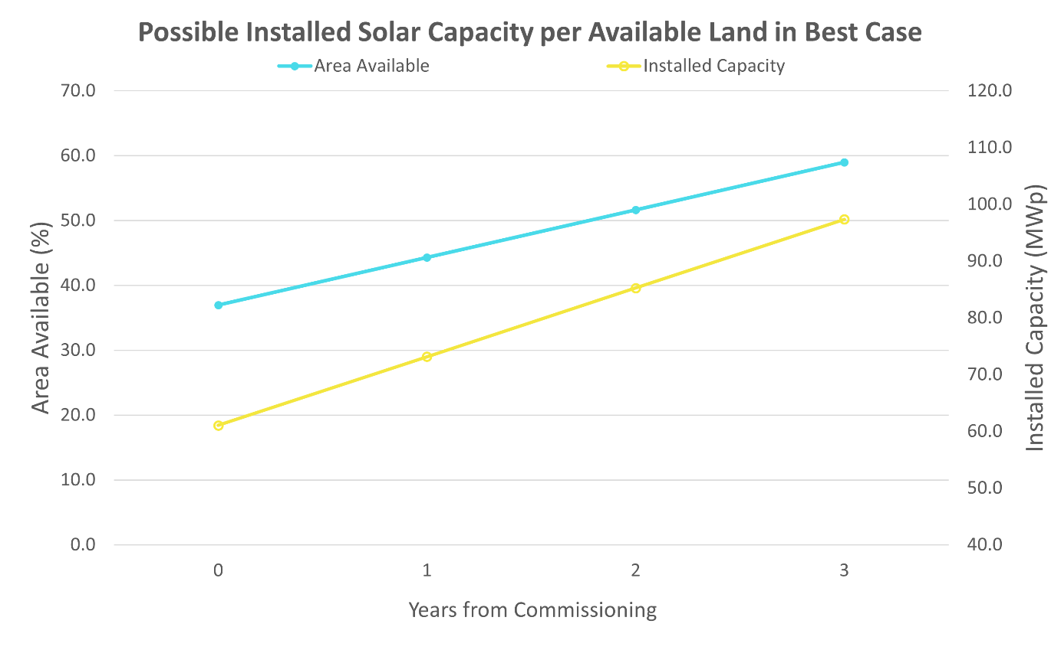

Figure 1: Possible installed solar capacity based on available land

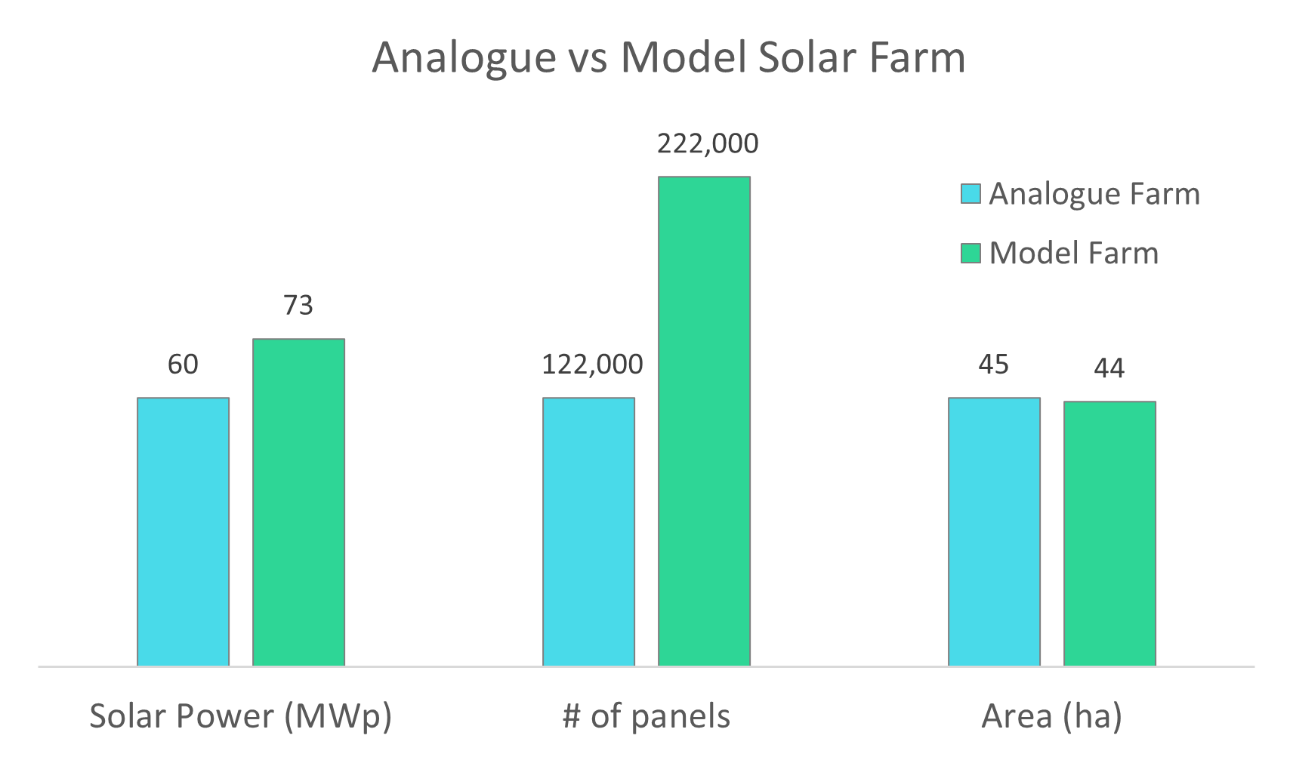

Figure 2: Comparison of solar power between analogue (from real operational farm) and model solar farm

Aside from the initial estimates of installed capacity, we also estimated the annual output from the development, assuming a 25-year production profile. We calculated low, best, and high case estimates by varying 3 key parameters in the estimation of annual production: (i) area availability, (ii) the operating factor (which is meant to account for meteorological conditions), and (iii) system inefficiencies. Table 2 summarises these key parameters along with other variables assumed for the modelled solar farm.

Table 2: Variables and assumptions for the low, best, and high cases of the model solar farm

|  |  |  |  |
| --- | --- | --- | --- |
| **Variable** | **Low** | **Best** | **High** |
| Area Availability | Some delays | No delays | Additional Space available |
| Operating Factor (%) | 60 | 75 | 90 |
| System Efficiency (%) | 70 | 80 | 90 |
| Days of Operation *(during years of initial development)* | 100 | 200 | 300 |
| Rate of Drop in Solar Module Efficiency | 0.5% / Year | | |
| Average Peak Sun Hours | 4.38 | | |

As the farm will likely be out of operation for several months during the first few years of development and installation, we estimate the days of operations during these years to be 100, 200, and 300 respectively in the low, best, and high cases. In all cases, we assume that the solar module efficiency reduces by 0.5% each year.

Finally, we assume an average of 4.38 peak sun hours based on data for Southeast Asia (detailed in Table 3), selecting the number based on representativeness of the region and of a potential offshore island farm.

Table 3: Peak sun hours for Southeast Asian countries based on minimum technical potential global horizontal irradiance (GHI). Minimum GHI data obtained from the “Global Solar Atlas 2.0”. (Global Solar Atlas, n.d.)

|  |  |
| --- | --- |
| **Country** | **Peak Sun Hours** |
| Vietnam | 3.29 |
| Indonesia | 3.9 |
| Lao People's Democratic Republic | 3.92 |
| Philippines | 4.01 |
| Myanmar | 4.19 |
| Malaysia | 4.26 |
| Singapore | 4.38 |
| Cambodia | 4.46 |
| Thailand | 4.55 |
| Timor-Leste | 4.66 |
| Brunei Darussalam | 4.72 |

As seen in Figure 3, peak electrical production occurs in year 4 when the full area of land is available for solar use. It can also be observed that solar output decreases over time, as increasing inefficiencies in the solar panel and overall system renders some components performing below full capacity. If large swaths of solar panels need full replacement periodically due to a system-wide failure, projected outputs would drop even further. Such scenarios could be modelled probabilistically to capture the randomness of such an event.

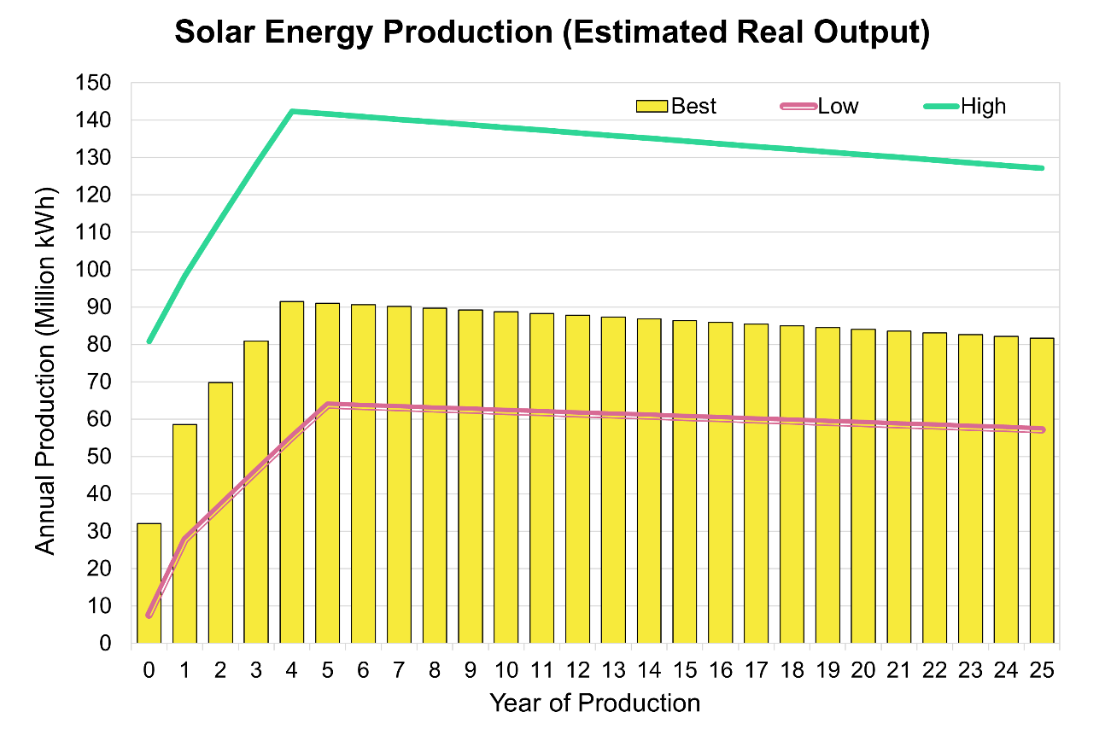

Figure 3: Low, best, and high cases of solar energy production throughout the solar farm’s assumed 25-year lifetime.

# GHG Emissions

## Emissions, Energy Content Factors, and Carbon Intensities

To model emissions, we gathered data on emissions factors (EF), energy content factors (ECF), and carbon intensities for various parts in a solar farm based on publicly available data. Some of this data is shown in Table 6, which lists the carbon intensities for materials, fuels, and components that contribute to the emissions of a solar farm over its entire life cycle. This includes the emissions given off during manufacturing, transportation, installation, operation, maintenance, and decommissioning. The key components at each of these stages are highlighted in Table 4, along with the emissions source for each component.

Table 4: Components at each stage of a solar farm's life cycle and their respective sources of emissions

|  |  |  |  |  |  |
| --- | --- | --- | --- | --- | --- |
|  | Manufacturing | Transport | Installation & Operation | Maintenance & Upkeep | Decommissioning |
| Components | Solar Panels, Inverters, Batteries, HVDC cable | Vessels | Vehicles, Subsea Installation Vessels | Ground Vehicles | Solar Panels, Inverters, Batteries |
| Sources of Emissions | Mining, Water consumption,  Silicon feedstock | Fuel Consumption | Fuel Consumption | Fuel Consumption | Recycling/Disposal |
| Considerations | Source country for raw materials, refining, & assembly | Type of vehicles &  Source and end points | Type of vehicles &  Manpower to operate vehicles | Type of vehicles  Manpower to operate vehicles | Distance to recycling plant (possible additional transport) |

Most of the carbon intensities are from the manufacture and decommissioning processes, as onshore operation processes for components (aside from fuelling and yearly maintenance works) are considered negligible here.

Emissions from fuel consumption were calculated using appropriate EFs and ECFs using Equation 1 below.

|  |  |
| --- | --- |
|  | Equation 1 |

The EF and ECF values used in our calculations are listed in Table 5.

Table 5: Energy content and emissions factors for different fuels based on Australia’s 2022 National Greenhouse Accounts Factors (2022)

|  |  |  |  |  |  |
| --- | --- | --- | --- | --- | --- |
| **Fuel Type** | **Energy Content Factor** | | **Emission Factor**  (Tonnes CO2eq/GJ) | | |
| Value | Units | CO2 | CH4 | N2O |
| Diesel | 38.6 | GJ/kL | 0.0699 | 0.0001 | 0.0002 |
| Natural Gas (Unprocessed) | 0.0393 | GJ/m3 | 0.0514 | 0.0001 | 0.00003 |

Table 6: Carbon intensities of different components in a solar farm

|  |  |  |  |  |  |
| --- | --- | --- | --- | --- | --- |
| **Carbon Intensities** | | | | | |
| **Fuel** | | | | | |
| **Fuel Type** | **Value** | | | **Units** | **References** |
| Natural gas | 0.185508 | | | kgCO2eq/kWh | Calculated based on Table 5 |
| **Solar modules** | | | | | |
| **Process** | **Low** | **Best** | **High** | **Units** | **References** |
| Manufacturing | 1.32 | 2.01 | 2.7 | kgCO2eq/Wp | (Yue, You, & Darling, 2014) |
| Decommissioning | 1.5 | 1.65 | 1.8 | gCO2e/ kWh | (Frankl et al., 2005) |
| **Inverters** | | | | | |
| **Process** | **Value** | | | **Units** | **References** |
| Manufacturing | 44.3 | | | kgCO2eq/kW | (Huawei, 2020) |
| Decommissioning | 0.43 | | | kgCO2eq/kW | (Huawei, 2020) |
| **Battery** | | | | | |
| **Process** | **Value** | | | **Units** | **References** |
| Manufacturing | 83 | | | kgCO2eq/Kwh | (Emilsson & Dahllöf, 2019) |
| Decommissioning | 15 | | | kgCO2eq/Kwh | (Romare & Dahllöf, 2017) |
| **Cables** | | | | | |
| **Process** | **Low** | **Best** | **High** | **Units** | **References** |
| Manufacturing | 3 | 4.5 | 5.9 | kgCO2eq/kg | (Harrison et al., 2010) |
| **Pipes** | | | | | |
| **Process** | **Low** | **Best** | **High** | **Units** | **References** |
| Manufacturing | 1.77 | 2.3 | 2.82 | kgCO2eq/kg | (Harrison et al., 2010) |

Lastly, specifications for the different components were based on analogue products and models from various companies summarised in Table 7. It is important to note that the selection of these components does not represent any endorsement of these products as being the most ideal for solar farms in general. If the exact models that will be used in the solar farm you are modelling are known, specifications of those products should be used for more accurate models of GHG estimation.

Table 7: Product models used as analogues for various components.

|  |  |
| --- | --- |
| **Component** | **Analogue Model** |
| Solar Module | FuturaSun FU 330P Polycrystalline Photovoltaic Module |
| IDT Inverter | ABB central inverters, PVS800, 100 to 500 kW |
| Inverter and Battery | Siemens & AES Fluence Sunstack |
| Pipe | Tioga Pipes |
| Transmission Cable | Sumitomo Electric |

## Scope 1

The assumptions for Scope 1 emissions are divided into the solar panel modelling, inverter modelling, IDT modelling, and battery modelling aspects. For solar panels, we assume solar panels have 330Wp and take up 2m2 each, resulting in a total of 185,000 panels which can be installed in available land in the first year. Installation of the panels is expected to require heavy vehicles and construction equipment; thus, we assume 5 units of heavy machinery will be used – each emitting 10 tonnes of CO2e per year. The installation is expected to be between one and six months long. Operations emissions are expected to be small and is estimated to be 2-8% of the emissions from installation. Depending on whether the panels are mono or multi-Si PV units, decommissioning emissions can be between 1.5-1.8 gCO2e/kWh respectively. Seasonality, cloud cover, and replacement of panels were not modelled, and hence future modelling work is needed to stress-test these assumptions.

Installation emissions for inverters, IDTs and batteries have been rolled up together with solar panel installations. 158 inverters are modelled, operating for 8 hours each day and being idle for 16. The power consumed during each period is 600W and 55W respectively. IDTs are assumed to emit the equivalent of 100-300 inverter units. We have assumed that battery storage will have enough storage capacity for the whole solar farm output. Batteries are assumed to not consume energy in daily operations, while any emissions from maintenance of them are rolled up with overall maintenance emissions on the farm. The end-of-life decommissioning emissions from batteries are at 15 kgCO2e/kWh, based on a 2017 IVL Swedish Environmental Research Institute study which considers both disposal and recycling of lithium batteries (Romare & Dahllöf, 2017).

As these battery emissions are significant, it is important to consider whether they will be used for the solar farm and to what extent. To analyse the breadth of scenarios, we model a solar farm for two cases: a “maximum flexibility” case where all generated power is stored in batteries, and a “minimum cost” case where no batteries are used, and power is consumed immediately. Both cases are compared to a “do nothing” case where power is simply generated from natural gas.

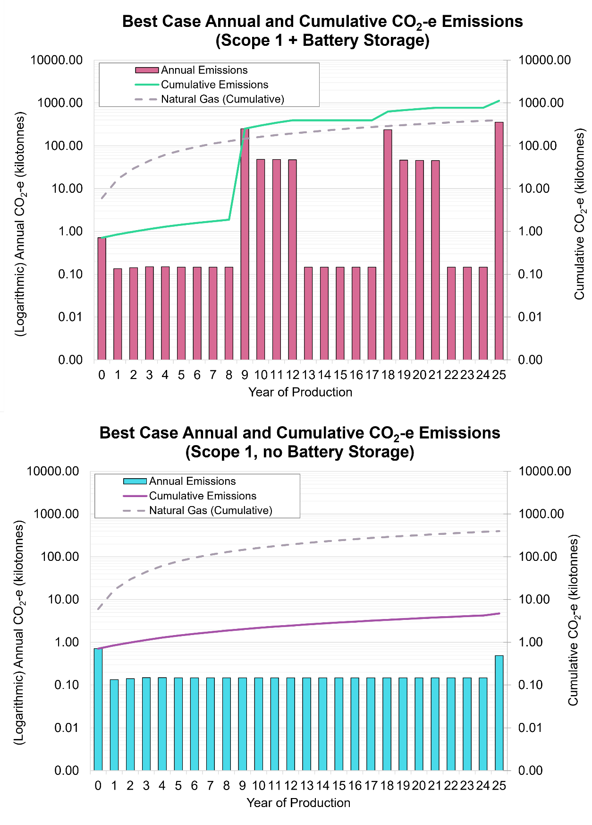

Figure 4: Scope 1 CO2-e emissions for the solar farm with batteries (top) and without batteries (bottom)

It is clear from Figure 4 that overall scope 1 emissions increase greatly with the addition of batteries. These large cyclical emissions arise mainly from battery decommissioning at the end of their lifespan, resulting in 350 kilotonnes of CO2e every 8 years. Without the batteries, emissions only peak at 0.7 kilotonnes of CO2e initially, mainly due to the installation of subsea cables. The rest of the yearly emissions increase gradually over time as solar production declines with time. These smaller emissions are mainly from energy consumed to power the inverter and IDT operations. The energy for these operations is assumed to come from natural gas as the inverters consume power even when idle and hence need a stable supply of energy. The peak at the 25th year is from decommissioning of all components except the subsea cables. Hence, the installation and decommissioning are the only two carbon intensive events in the solar farm life cycle in this case.

When compared to the “do nothing” scenario of using natural gas to produce the same power, the no-battery “minimum cost” scenario has nearly 84 times lower emissions. However, with batteries added for the “maximum flexibility” scenario, cumulative emissions from the solar farm exceed that of just using natural gas. It should be noted, however, that this is a very pessimistic scenario which assumes all power generated is stored in batteries, when likely only a fraction of it would be stored and the rest of the power consumed immediately upon generation. It is reasonable to infer therefore that with proper optimisation, solar farms with batteries can still have less emissions than electricity from natural gas combustion.

## Scope 2

Scope 2 emissions are mainly focused on electricity consumption post-generation and hence requires an understanding of the power consumption of the facility. As this information is unlikely to be known at the early prospective stage of the solar farm, we have not modelled scope 2 emissions in this study. Further along the development of the solar farm, data and estimates of office and facility electricity consumption can be covered in the scope 2 emissions when known. With scope 2 emissions included, however, the carbon intensity of solar farms will increase.

## Scope 3

Scope 3 emissions are emissions that are a consequence of activities of the company but not from sources owned or controlled by the company. This makes scope 3 the hardest category to estimate as it is highly dependent on the end user of the products from the solar farm. For simplicity, we model scope 3 emissions related to the manufacturing and transport of the components of the solar farm only.

Carbon intensities from the manufacturing of components were outlined in Table 6. Batteries were assumed to have an 8-year lifespan and hence three installation cycles were modelled for a 25-year solar farm life cycle. Transport of all components are modelled with one shipment per year, using a vessel which consumes 21kL of diesel per day. The number of days required for shipment per year likely varies due to prevailing weather conditions and factory output, but shipments are assumed to take 5, 10, or 15 days in the low, best, and high cases respectively.

The main source of scope 3 emissions is the manufacturing of solar panels, which contribute roughly 120 kilotonnes of CO2e in the first year of operations alone, when the bulk of solar panels are installed. Battery manufacturing is the next largest source, exacerbated by the fact they need to be replaced every 8 years. The manufacturing of both solar panels and batteries is an energy intensive process due to the mining and purification processes needed for the materials within these components. Consequently, their manufacturing footprint also depends on the energy mix where they were mined and produced. In China for example, solar panel manufacturing has twice the carbon footprint of Europe, as China’s primary mean of power generation is through coal combustion.

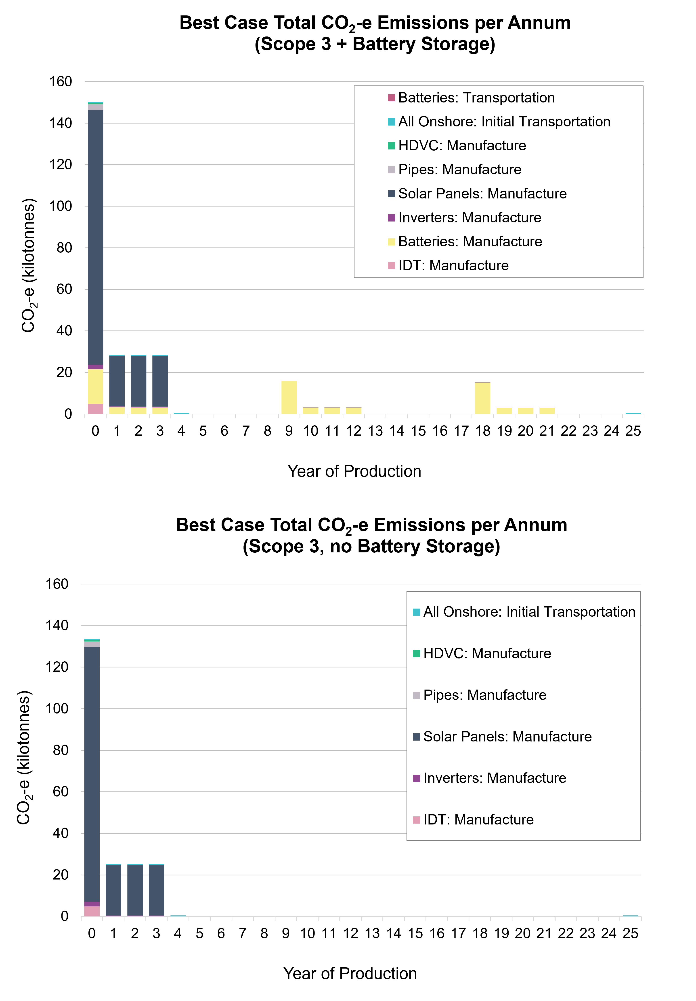

Figure 5: Scope 3 CO2-e emissions for the solar farm with batteries (top) and without batteries (bottom)

## Overall emissions

In our emissions model, battery decommissioning from scope 1 and solar panel and battery manufacturing from scope 3 form the bulk of all emissions from the solar farm. The greatest uncertainty in GHG emissions thus comes from the presence of batteries, which add to the capital cost of the solar farm, in addition to the emissions. However, the added flexibility for operations that they provide might make the use of batteries worth the cost. In this case, careful optimisation of the number and deployment of batteries is needed to reduce emissions and maximise benefit.

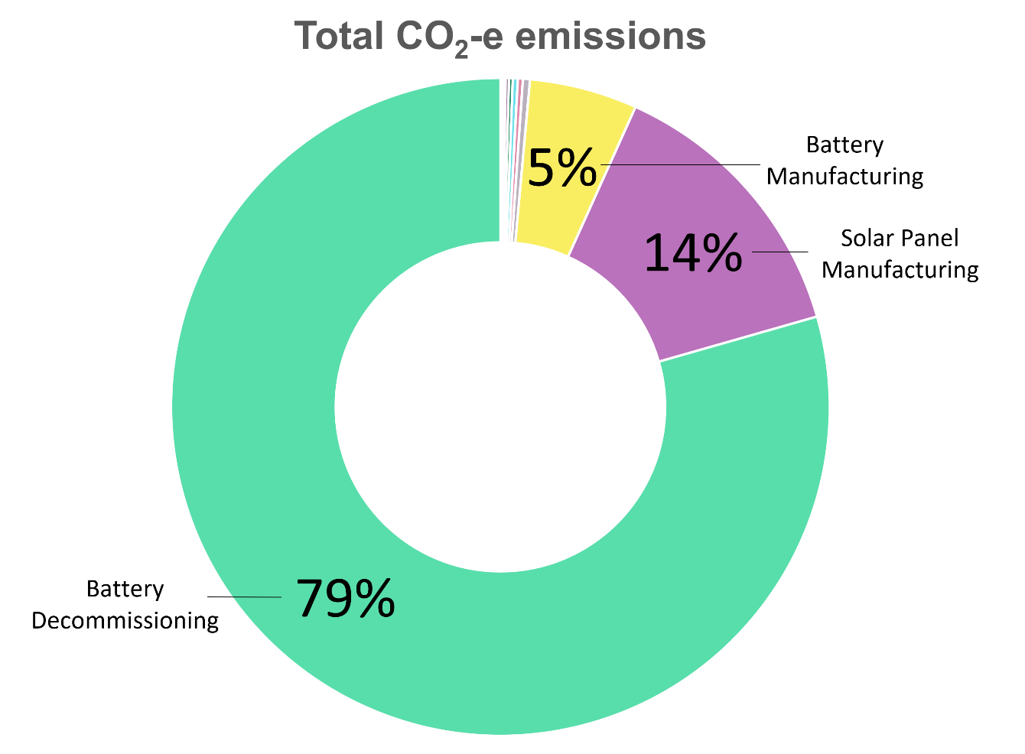

Figure 6: Contribution of activities to the total CO2-e emissions of the solar farm

# Cost Modelling

## Weighted Average Cost of Capital (WACC)

To model costs, we calculate a WACC based on assumptions indicated in Table 8 below which also include the references for assumptions. Using a 5-year historical average of the Uniform Singapore Energy Price (USEP), a Power Purchase Agreement (PPA) price of 88.7 SGD/MWh was estimated. A USD-to-SGD foreign exchange rate of 1.34 was assumed based on a historical 12-month average. Costs and prices were determined in real terms (as of the time of calculation), then inflated at a 2% rate per annum.

Table 8: Assumptions used in the calculation of the WACC.

|  |  |  |
| --- | --- | --- |
| Variable | Assumption | References & Remarks |
| Beta | 1 | Assuming same risk as overall economy |
| Equity Risk Premium | 4.38% | Singapore equity risk premium estimate (Damodaran, 2021) |
| Debt Premium | 2.85% | 5-year Singapore bond yield 3Q22 forecast (OCBC, 2022) |
| Tax Rate | 17% | Singapore's prevailing corporate tax rate (IRAS, n.d.) |
| Inflation Rate | 2% | Assumption based on 2021 inflation rates for Singapore |

## CAPEX, OPEX, and Payback Period

Modelling the CAPEX and OPEX are important as they directly impact the profitability of the project. The cost analysis for this study utilises open-source information and industry averages – contractor margins, balance of system, civil and infrastructure costs, and others have not been factored. This therefore represents an optimistic outlook for the solar farm costs.

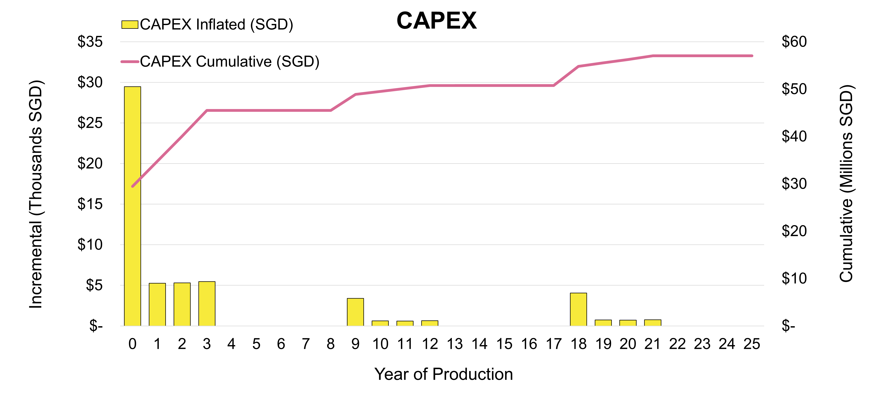

Figure 7: Modelled CAPEX for the solar farm

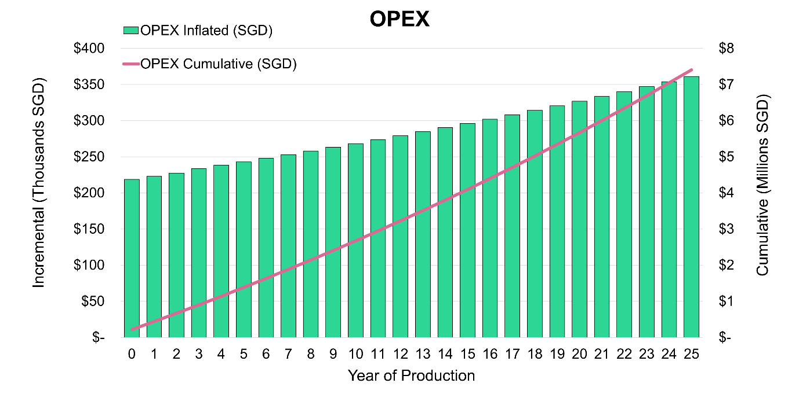

Figure 8: Modelled OPEX for the solar farm

Combining the CAPEX and OPEX shows a solar farm to be a highly capital-intensive endeavour, costing upwards of SGD$64 million over its lifetime. However, assuming a PPA price of 88.7 SGD/MWh, the generated revenue from the solar farm could be as much as SGD$250 million – more than enough to offset the costs within the 25-year timeframe.

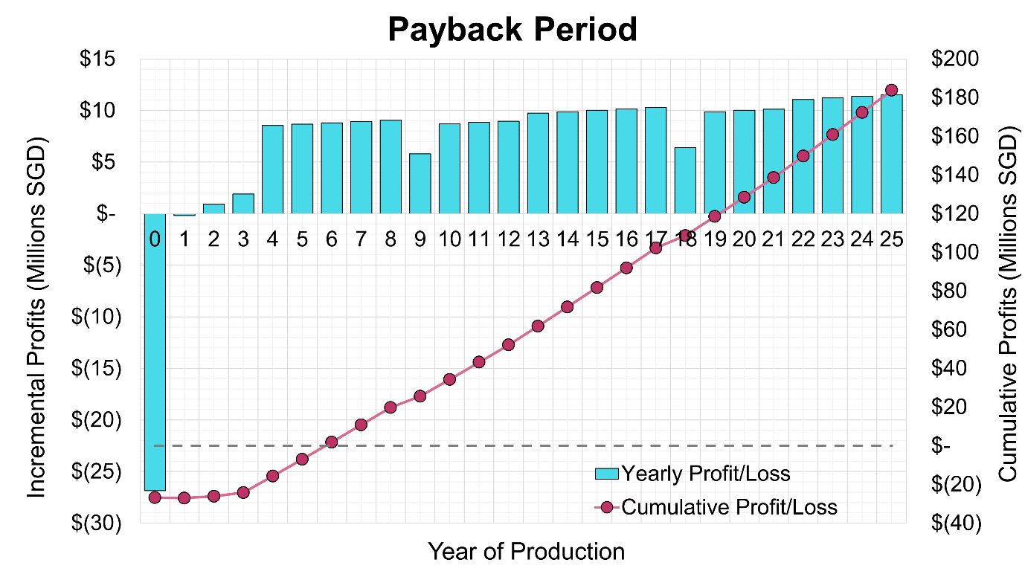

Figure 9: Annual profits and cumulative profits for the solar farm, showing its payback period of about 6 years.

Based on the model, the minimum payback period (PP) is 6 years, with positive cash flow after. This is in line with PPs from analogues in literature, which indicates 2 to 13 years before payback (Suphahitanukool, et al., 2018; Kessler, 2017; Marimuthu, Kirubakaran, & Rajasekaran, 2014; Paton, Tan, & Reindl, 2019). There are noticeable dips in the annual profits which are associated with capital costs during years where batteries need to be replaced. Note that solar panel replacement has not been modelled here and this may further extend the breakeven point.

# Conclusion

A high-level LCA of a prospective solar farm shows that benefits from solar can be negated depending on how extensively batteries are used as part of the development. In our model, we found battery decommissioning to be the most carbon intensive activity for the solar farm, followed by manufacturing of the batteries as well as solar panels. This creates peaks in emissions at the start and end of the project life cycle, as well as during any periods of battery replacements. Doing away with battery storage would dramatically decrease emissions and lower costs, but this would be at the expense of operational flexibility and thus optimisation of the number and deployment of batteries is recommended if that is what meets the needs of the project.

Our work also demonstrates the PP for these solar farms. We find that solar farms are highly capital intensive, but PPs are generally in the earlier half of a solar farm’s assumed 25-year lifetime. We have shown that PP is affected by the replacement of solar panels and batteries.

A high-level LCA such as the one demonstrated here offers insight into the environmental benefits, especially when benchmarked against a fossil fuel dependent development. Another use of such an assessment is that it provides stakeholders with an appreciation of where highest emissions could originate from, and possible optimisations to consider for the project, before committing large sums of money to development.

# Limitations

Data and models used in this study rely on a medley of different public sources and analogues. Many assumptions have been used in our calculations which may or may not reflect true conditions on an actual solar site. Nevertheless, the methods employed, and considerations made can be repeated with better data in the LCA of other solar farms in their prospective stages.

# Acknowledgment

The authors would like to thank XX for peer review of this work.

# Funding

This research did not receive any specific grant from funding agencies in the public, commercial, or not-for-profit sectors.

# Nomenclature

|  |  |
| --- | --- |
| **ABEX** | Decommissioning expenditure |
| **CAPEX** | Capital expenditure |
| **CH4** | Methane |
| **CO2** | Carbon dioxide |
| **CO2-e** | Carbon dioxide equivalents |
| **g** | gram |
| **GHG** | Greenhouse gas |
| **GJ** | Gigajoule |
| **ha** | Hectare |
| **HVDC** | High voltage direct current |
| **J** | Joule |
| **kg** | Kilogram |
| **kL** | kilolitre |
| **Kwh** | Kilowatt-hour |
| **L** | Litre |
| **LCA** | Life Cycle Assessment |
| **m** | Metre |
| **MWp** | Megawatt peak |
| **N2O** | Nitrous oxide |
| **OPEX** | Operational expenditure |
| **PP** | Payback period |
| **Twh** | Terrawatt-hour |
| **Wp** | Watt peak |

# References

Damodaran, A. (2021). *Country Risk: Determinants, Measures and Impications - The 2021 Edition.* New York, USA: Stern School of Business.

Department of Climate Change, Energy, the Environment, and Water. (2022). *National Greenhouse Accounts Factors: 2022.* Retrieved from https://www.dcceew.gov.au/climate-change/publications/national-greenhouse-accounts-factors-2022

Emilsson, E., & Dahllöf, L. (2019). *Lithium-Ion Vehicle Battery Production.* Stockholm, Sweden: IVL Swedish Environmental Research Institute. Retrieved from https://www.ivl.se/download/18.34244ba71728fcb3f3faf9/1591706083170/C444.pdf

Frankl, P., Menichetti, E., Raugei, M., Lombardelli, S., & Prennushi, G. (2005). *Final report on technical data, costs and life cycle inventories of PV applications.* Deliverable 11.2-RS Ia of the NEEDS (New Energy Externalities Development for Sustainability) Integrated Project, Rome, Italy.

Global Solar Atlas. (n.d.). *Global Solar Atlas 2.0*. Retrieved from Global Solar Atlas: https://globalsolaratlas.info

Harrison, G. P., Maclean, E. J., Karamanlis, S., & Ochoa, L. F. (2010). Life cycle assessment of the transmission network in Great Britain. *Energy Policy*, 3622-3631. doi:10.1016/j.enpol.2010.02.039

Huawei. (2020). *Product Carbon Footprint Report.* Shenzhen, China: Huawei.

IEA. (2022). *Renewables 2022.* IEA Publications.

IEA. (2023). *Solar PV*. Retrieved from International Energy Agency: https://www.iea.org/energy-system/renewables/solar-pv

IRAS. (n.d.). *Corporate Income Tax Rates*. Retrieved from Inland Revenue Authority of Singapore : https://www.iras.gov.sg/quick-links/tax-rates/corporate-income-tax-rates

Kessler, W. (2017). Comparing energy payback and simple payback period for solar photovoltaic systems. *E3S Web of Conferences* (p. 80). EDP Sciences. doi:https://doi.org/10.1051/e3sconf/20172200080

Marimuthu, C., Kirubakaran, V., & Rajasekaran, R. (2014). Energy pay back period and carbon pay back period for solar photovoltaic power plant. *Gas, 20*, 9-81.

OCBC. (2022). *Interest Rate Forecasts (Aug).* OCBC Treasury Research. Retrieved from https://www.ocbc.com/iwov-resources/sg/ocbc/gbc/pdf/fx%20outlook/interest%20rates/interest%20rate%20and%20bond%20yields%20forecast%20(aug%2022).pdf

Paton, C., Tan, C., & Reindl, T. (2019). *Solar Economics Handbook of Singapore.* Singapore: Solar Energy Research Institute of Singapore (SERIS).

Romare, M., & Dahllöf, L. (2017). *The life cycle energy consumption and greenhouse gas emissions from lithium-ion batteries.* Stockholm, Sweden: IVL Swedish Environmental Research Institute. Retrieved from https://www.ivl.se/download/18.34244ba71728fcb3f3fa2f/1591705755278/C243.pdf

Suphahitanukool, C., Hunsacharoonroj, I., Usapein, P., Khedari, J., Waewsak, J., & Hirunlabh, J. (2018). An Evaluation of Economic Potential Solar Photovoltaic Farm in Thailand: Case study of Polycrystalline Silicon and Amorphous Silicon Thin Film. *International Journal of Energy Economics and Policy, 8*(4), 33-41.

Yue, D., You, F., & Darling, S. B. (2014). Domestic and overseas manufacturing scenarios of silicon-based photovoltaics: Life cycle energy and environmental comparative analysis. *Solar Energy, 105*, 669-678. doi:10.1016/j.solener.2014.04.008